Product information sheet
Supplier’s name or trade mark: TESPA ELEKTRİK PAZARLAMA SAN. LTD. ŞTİ
Supplier’s address (¹) : EMEKYEMEK MAH. YANIKKAPI SOK. NO:32/D BEYOĞLU/İSTANBUL/TÜRKİYE
Model identifier: G95-4W
Type of light source: LED BULB
Lighting technology used: |  | LED | Non-directional or directional: | NDLS
Light source cap-type (or other electric interface) |  | E27
Mains or non-mains: |  | MLS | Connected light source (CLS): | NO
Colour-tuneable light source: |  | NO | Envelope: | -
High luminance light source: |  | NO
Anti-glare shield: |  | NO | Dimmable: | NO
Product parameters
Parameter |  | Value | Parameter | Value
General product parameters:
Energy consumption in on-mode (kWh/1 000 h) |  | 4 | Energy efficiency class | F
Useful luminous flux (Φ_{use}), indicating if it refers to the flux in a sphere (360°), in a wide cone (120°) or in a narrow cone (90°) |  | 370Lm | Correlated colour temperature, rounded to the nearest 100 K, or the range of correlated colour temperatures, rounded to the nearest 100 K, that can be set | 2500K
On-mode power (P_{on}), expressed in W |  | 4 | Standby power (P_{sb}), expressed in W and rounded to the second decimal | 0,5
Networked standby power (P_{net}) for CLS, expressed in W and rounded to the second decimal |  | - | Colour rendering index, rounded to the nearest integer, or the range of CRI-values that can be set | 80
Outer dimensions without separate control gear, lighting control parts and non-lighting control parts, if any (millimetre) | Height | 108 | Spectral power distribution in the range 250 nm to 800 nm, at full-load | 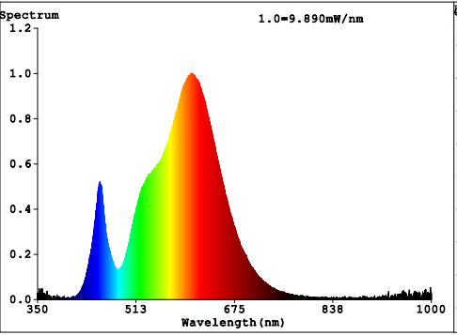
 | Width | 60
 | Depth | 60
Claim of equivalent power (³) |  | YES | If yes, equivalent power (W) | 40
 |  |  | Chromaticity coordinates (x and y) | x=0.4833 y=0.4185
Parameters for directional light sources:
Peak luminous intensity (cd) |  | N/A | Beam angle in degrees, or the range of beam angles that can be set | 360
Parameters for LED and OLED light sources:
R9 colour rendering index value |  | 1 | Survival factor | 0,90
the lumen maintenance factor |  | 0,94
Parameters for LED and OLED mains light sources:
displacement factor (cos φ1) |  | 0,50 | Colour consistency in McAdam ellipses | 6
Claims that an LED light source replaces a fluorescent light source without integrated ballast of a particular wattage. |  | - | If yes then replacement claim (W) | -
Flicker metric (Pst LM) |  | 1 | Stroboscopic effect metric (SVM) | 0,4

